Factors - Answers

Key Stage 2: 2003 Paper A
1.
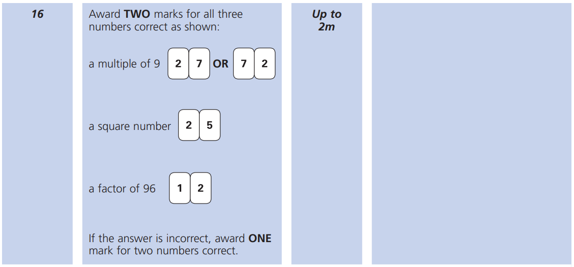
Key Stage 2: 2005 Paper B
1.
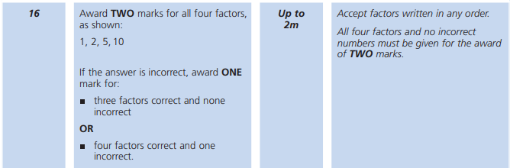

Key Stage 2: 2006 Paper A
1.
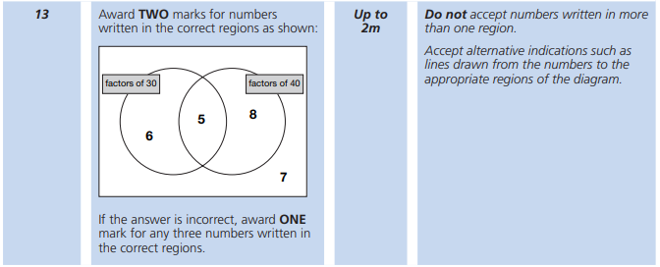
Key Stage 2: 2009 Paper A
1.
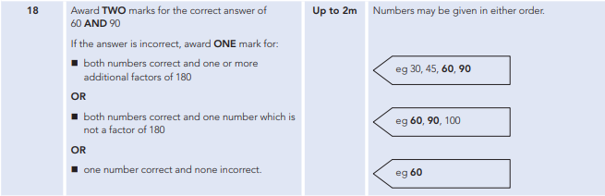
Key Stage 2: 2012 Paper B L6
1.
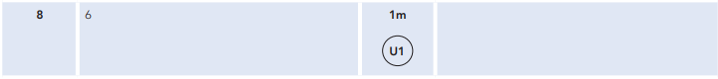

Key Stage 2: Paper 2 and 3 Reasoning - Sample
1.
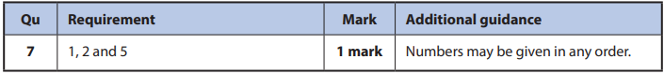
Key Stage 2: 2017 Paper 3 Reasoning
1.
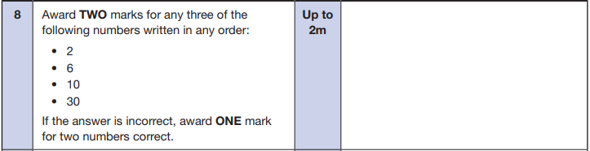
Key Stage 2: 2018 Paper 3 Reasoning
1.
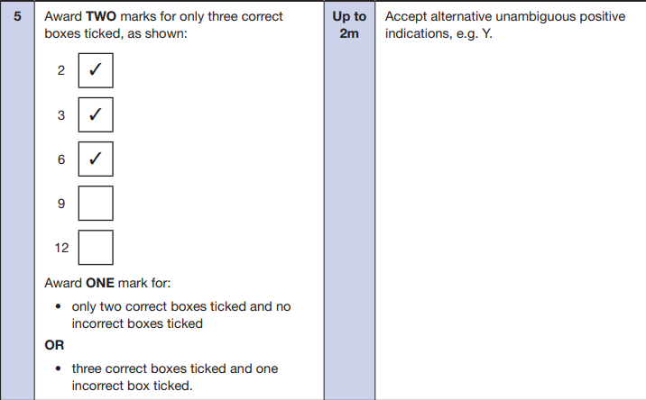

Key Stage 2: 2019 Paper 3 Reasoning
1.
